Coal Lab no 2

Jeevan Kumar (24k-0821)

**Qno 1**

**Code:**

include Irvine32.inc

.data

var1 SBYTE 10

var2 SWORD -45

.code

main

main ENDP

END main

**Qno 2**

**Code:**

include Irvine32.inc

.data

var1 SBYTE 10

var2 SWORD -45

var3 SWORD -32768

.code

main PROC

main ENDP

END main

**Qno 3**

**Code:**

**include Irvine32.inc**

**.data**

**rollno BYTE "24k-0821",0**

**v1 BYTE 32**

**v1 BYTE 32**

**v3 BYTE 17**

**v4 BYTE 24**

**v5 BYTE 12**

**.code**

**main PROC**

**main ENDP**

**END main**

**Qno 4**

**Code:**

include Irvine32.inc

.data

rollno BYTE "24k-0821", 0

v1 DWORD 12h

v2 DWORD 0Ah

v3 DWORD 25h

v4 DWORD 70h

.code

main PROC

mov eax, v1

sub eax, v2

mov ebx, eax

mov eax, v1

add eax, v2

sub ebx, eax

add ebx, v4

add ebx, v3

mov eax, ebx

call WriteDec

main ENDP

END main

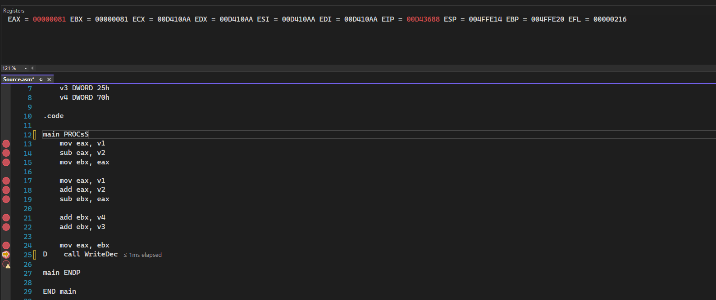

**Qno 5**

Code : include Irvine32.inc

.data

rollno BYTE "24k-0821", 0

v1 BYTE 00010010b

v2 BYTE 00001010b

v3 BYTE 00100101b

v4 BYTE 01110000b

.code

main PROC

mov al, v1

sub al, v2

mov bl, al

mov al, v1

add al, v2

sub bl, al

add bl, v4

add bl, v3

mov al, bl

call WriteDec

main ENDP

END main

Output:

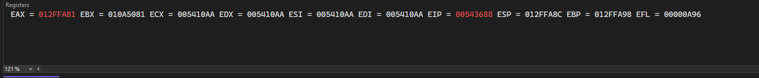

Qno 6

**Code:**

**include Irvine32.inc**

**.data**

**rollno BYTE "24k-0821",0**

**dArray BYTE 10,20,30**

**.code**

**main PROC**

**main ENDP**

**END main**

**Qno 7**

**Code:**

**include Irvine32.inc**

**.data**

**dArray DWORD 50 DUP(?)**

**.code**

**main PROC**

**ENDP**

**END main**

**Qno 8**

**Code:**

**include Irvine32.inc**

**.data**

**str DWORD 300 DUP("COAL")**

**.code**

**main PROC**

**main ENDP**

**END main**

**Qno9**

**Code:**

**include Irvine32.inc**

**.data**

**bArray BYTE 10 DUP(0)**

**.code**

**main PROC**

**main ENDP**

**END main**